PROJECT REPORT OF INDUSTRY ORIENTED HANDS-ON EXPERIENCE (IOHE) (Module-2)
ON
Multi-Modal AI-Based Health Intelligence Framework for Integrated Disease Risk Assessment and Lifestyle Analysis
submitted in partial fulfilment of the requirements for the award of degree of

BACHELOR OF ENGINEERING
In
COMPUTER SCIENCE AND ENGINEERING

Submitted by: Supervised By:
Rishi Raghav Singh RohanSingh Dr. Rajat Takkar
2210992162 2210992176
Organisation:
Chitkara University Institute of
Engineering and Technology


DEPARTMENT OF COMPUTER SCIENCE AND ENGINEERING

CHITKARA UNIVERSITY INSTITUTE OF ENGINEERING AND TECHNOLOGY
CHITKARA UNIVERSITY, PUNJAB, INDIA

TABLE OF CONTENTS

S.No. | Title | Page No.
1. | Declaration | 3
2. | Acknowledgement | 4
3. | Abstract | 5
4. | Introduction | 6
5. | Methodology | 8
6. | Tools and Technologies | 10
7. | Implementation | 10
8. | Major Findings/Outcomes/Output/Results | 12
9. | Snapshots | 14
10. | Code Snippets | 16
11. | Conclusion and Future Scope | 19
12. | References | 20
13. | Appendices | 21

DECLARATION

I hereby certify that the work which is being presented in the project report entitled “Multi-Modal AI-Based Health Intelligence Framework for Integrated Disease Risk Assessment Lifestyle Analysis” in partial fulfilment of requirement for the award of the degree of Bachelor of Engineering (Computer Science and Engineering) submitted in the department of Computer Science and Engineering at Chitkara University Institute of Engineering and Technology, Chitkara University, Punjab, India, is an authentic record of my own work carried out under the supervision of Dr. Rajat Takkar. The matter presented in this project report has not been submitted in any other university/institute for the award of any degree.

Place: Rajpura Rishi Raghav Singh Rohan Singh
Date: 16 May 2026 2210992162 2210992176

This is to certify that the above statement made by the candidate is correct to the best of my knowledge and belief.

Dr. Rajat Takkar
Department of Computer Science and Engineering
Chitkara University Institute of Engineering and Technology,
Chitkara University, Punjab, India

ACKNOWLEDGEMENT
We would like to express our sincere gratitude to our mentor for their valuable guidance, continuous support, and encouragement throughout the completion of this project. Their insights and suggestions helped us gain a deeper understanding of cloud automation and Infrastructure as Code.
We are also thankful to Chitkara University Institute of Engineering and Technology for providing us with the necessary resources and a supportive environment to successfully carry out this work.
We would like to acknowledge the efforts and cooperation of all team members, whose collaboration and dedication played a key role in the successful completion of this project.
Finally, we express our heartfelt thanks to our families and friends for their constant motivation and support throughout this journey.

ABSTRACT

More than 30% of worldwide deaths involve diseases caused by cardiovascular and lifestyle factors (WHO, 2023). As awareness of early risk identification advances, accessible practical screening tools for use in primary care continue to be either very expensive, reliant on specialists, or both. This report describes the design, implementation, and evaluation of a Multi-Modal AI-Based Health Intelligence Framework with two interrelated modules: the Disease Risk Assessment (DRA) module and the Lifestyle Analysis (LSA) module.
The DRA module trains Logistic Regression, SVM (RBF kernel), and Random Forest classifiers on the Cleveland Heart Disease dataset (303 patients) after systematic preprocessing and class-balancing via SMOTE. The LSA module takes user-reported behavioural inputs — BMI, physical activity, sleep, dietary quality, and stress — to calculate a composite Lifestyle Risk Index (LRI). Both modules are integrated through a Streamlit web application providing real-time predictions with SHAP-based explanations.
Random Forest achieved the best performance with 91.8% accuracy and AUC-ROC = 0.956. The integrated Combined Health Risk Score (CHRS) demonstrated substantial agreement with physician ratings (Cohen's κ = 0.74). The system delivers sub-60 ms response times and is cloud-native deployable.

Keywords: Artificial Intelligence, Machine Learning, Multi-Modal Health Framework, Cardiovascular Risk Assessment, Lifestyle Analysis, Random Forest, SVM, Logistic Regression, Streamlit, SHAP Explainability, Clinical Decision Support, Preventive Healthcare.

- Introduction

  - Background and Context

Non-communicable diseases (NCDs), particularly cardiovascular diseases, are among the leading causes of mortality worldwide. According to the World Health Organization (WHO, 2023), cardiovascular diseases account for approximately 17.9 million deaths annually and contribute significantly to the global healthcare burden. Factors such as unhealthy diet, stress, obesity, poor sleep patterns, and lack of physical activity have increased the prevalence of lifestyle-related diseases in recent years.
With the advancement of Artificial Intelligence (AI) and Machine Learning (ML), healthcare systems are increasingly adopting intelligent prediction models for early disease diagnosis and preventive healthcare. AI-driven healthcare applications can analyse patient data efficiently, identify hidden risk patterns, and support medical decision-making. However, many existing systems focus only on either clinical biomarkers or lifestyle factors, resulting in incomplete health assessments.
The growing demand for accessible, affordable, and accurate healthcare screening systems has created the need for integrated multi-modal solutions capable of analysing both medical and behavioural health indicators together.

  - Problem Statement

Most existing AI-based healthcare prediction systems are single-modal in nature, meaning they analyse only clinical data or lifestyle information independently. Such systems fail to provide a comprehensive understanding of an individual’s overall health condition. For example, a patient with borderline clinical parameters but unhealthy lifestyle habits may remain undetected in traditional systems.
Additionally, many healthcare screening tools are expensive, require specialist supervision, and are not easily accessible in primary healthcare or low-resource environments. The absence of explainable and real-time prediction systems further limits user trust and practical usability.
Therefore, there is a need for an intelligent, explainable, and cost-effective healthcare framework that combines disease prediction with lifestyle analysis to support early risk identification and preventive healthcare.

  - Objectives

The primary objectives of this project are:

- To develop a Multi-Modal AI-Based Health Intelligence Framework for cardiovascular disease risk prediction.
- To integrate clinical health assessment and lifestyle behaviour analysis within a single system.
- To implement machine learning models such as Logistic Regression, Support Vector Machine, and Random Forest for disease prediction.
- To calculate a Lifestyle Risk Index (LRI) based on behavioural parameters including BMI, sleep quality, diet, stress, and physical activity.
- To provide real-time and explainable predictions using SHAP-based interpretability techniques.
- To design a user-friendly web application for accessible healthcare screening.
- To develop a scalable and cloud-deployable healthcare solution suitable for preventive healthcare systems.

  - Proposed Solution / Overview

The proposed system is a Multi-Modal AI Health Intelligence Framework consisting of two integrated modules:
Disease Risk Assessment (DRA) Module
The DRA module uses machine learning algorithms to predict cardiovascular disease risk based on clinical features. The system is trained using the Cleveland Heart Disease dataset containing 303 patient records and 13 clinical attributes. Multiple classifiers including Logistic Regression (LR), Support Vector Machine (SVM), and Random Forest (RF) are evaluated to determine the best-performing model.
The LSA module evaluates lifestyle-related behavioural factors such as BMI, dietary quality, physical activity, sleep duration, and stress levels. Based on these parameters, the system computes a Lifestyle Risk Index (LRI) to estimate overall lifestyle-related health risk.
Both modules are integrated into a Streamlit-based web application that provides real-time prediction results along with SHAP-based explainability, enabling users to understand the key factors influencing predictions.

  - Expected Outcome

The expected outcomes of the proposed project include:
- Accurate prediction of cardiovascular disease risk using machine learning techniques.
- Comprehensive health assessment through combined clinical and lifestyle analysis.
- Real-time prediction system with fast response time and user-friendly interaction.
- Improved healthcare accessibility for primary care and low-resource environments.
- Enhanced transparency and trust using explainable AI techniques.
- Cloud-ready deployment for scalable healthcare applications.
- Promotion of preventive healthcare and early disease detection.

  - Original Contribution

The major contribution of this project lies in the development of a multi-modal healthcare intelligence framework that combines both clinical disease prediction and lifestyle behavior analysis within a unified platform. Unlike conventional single-modal systems, the proposed framework provides a more holistic assessment of health risk.
Additional original contributions include:
- Integration of Disease Risk Assessment (DRA) and Lifestyle Analysis (LSA) modules.
- Development of a Lifestyle Risk Index (LRI) for behavioural health evaluation.
- Use of SHAP-based explainable AI for transparent prediction analysis.
- Implementation of a lightweight, real-time, and cloud-deployable healthcare application.
- Providing an accessible and cost-effective AI-driven preventive healthcare solution suitable for broader healthcare adoption.

- Methodology

  - Dataset

The DRA module uses the Cleveland Heart Disease dataset, consisting of 303 patient records described by 13 clinical features and a binary disease label. Key features include: age, sex, chest pain type (cp), resting blood pressure (trestbps), serum cholesterol (chol), fasting blood sugar (fbs), resting ECG results (restecg), maximum heart rate (thalach), exercise-induced angina (exang), ST depression (oldpeak), number of fluoroscopic vessels (ca), and thalassemia type (thal).
The LSA module operates on user-provided inputs; no external dataset is required at inference time. Risk stratification thresholds are derived from NHANES (National Health and Nutrition Examination Survey) population-level norms.
Parameter | Measurement | Reference Standard | Risk Indicator
BMI | kg/m² (computed) | WHO: Normal 18.5–24.9 | BMI > 30 = Obese
Physical Activity | Hours/week (self-report) | AHA: ≥150 min/week moderate | < 2.5 hrs = Sedentary
Sleep Duration | Hours/night (self-report) | NSF: 7–9 hrs for adults | < 6 or > 9 hrs = Risk
Dietary Quality Scor | 0–10 scale () | HEI-2020 criteria | Score < 5 = Poor diet

  - Preprocessing Pipeline

A unified Scikit-learn preprocessing pipeline is serialized via joblib. The same transformations applied during training are reused at inference to prevent data leakage.
- Stage 1 — Imputation: Six records with missing ca and thal values were imputed using the modal value within each class label.
- Stage 2 — Encoding: Categorical features (cp, restecg, thal, slope) were one-hot encoded, expanding the feature space from 13 to 19 dimensions.
- Stage 3 — Scaling: Continuous features standardized to zero mean and unit variance using StandardScaler, fitted only on training data.
Stage 4 — SMOTE Oversampling: Applied exclusively within training folds to create synthetic minority samples, avoiding validation performance inflation.

  - Machine Learning Classifiers

Three classifiers are trained and compared using 5-fold stratified cross-validation with a nested 3-fold inner loop for hyperparameter optimization.

Logistic Regression (LR): Applies a sigmoid function to a linear combination of input features. Regularization parameter λ = 0.1 was selected via nested cross-validation. The model predicts disease probability as: P(y=1|x) = 1 / (1 + exp(-(βᵀx + β₀))).

Support Vector Machine (SVM-RBF): Finds an optimal separating hyperplane in a kernel-mapped feature space. Hyperparameters C = 1.0 and γ = 0.1 were selected via grid search. Platt scaling was applied for probability calibration.

Random Forest (RF): Ensemble of 200 decision trees trained on bootstrapped samples with √d features per split. Final prediction by majority vote: ŷ = mode{tₖ(x) : k = 1, …, 200}. Node splits minimize Gini impurity.

  - Lifestyle Risk Index (LRI)
The LSA module computes an LRI bounded in [0, 1]:
LRI = Σⱼ wⱼ · rⱼ(xⱼ) subject to Σⱼ wⱼ = 1, wⱼ > 0
The weight vector W = [0.25, 0.25, 0.20, 0.15, 0.15] is assigned to {BMI, Physical Activity, Sleep Duration, Dietary Quality, Stress Level} based on AHA Cardiovascular Health (CVH) guidelines. Risk tiers: Low (LRI < 0.35), Moderate (0.35–0.65), High (> 0.65)

  - Combined Health Risk Score (CHRS)
Both modules are combined into an integrated score: CHRS = α · P_DRA + (1 − α) · LRI, with α = 0.65, giving priority to clinically measured data over self-reported inputs. CHRS maps to: Green (< 0.25), Yellow (0.25–0.50), Orange (0.50–0.75), Red (> 0.75).

- Tools and Technologies
Tool / Technology | Purpose
Python 3.10+ | Primary language for ML pipeline, data processing, and application logic
Scikit-learn | ML classifiers (LR, SVM, RF), preprocessing pipeline, SMOTE, joblib serialization
Streamlit | Interactive web UI with real-time predictions, classifier switching, and downloadable reports
SHAP Library | Feature-level explainability for every prediction in DRA and LSA modules
Pandas / NumPy | Data manipulation, feature engineering, statistical computation
Pydantic | Input validation: PatientInput and PredictionResponse schemas
Joblib | Model and pipeline serialization with gzip compression
Docker | Multi-stage containerized build for cloud-native, reproducible deployment
Pytest | Unit testing for DRA inference pipeline and LSA scoring module
Cleveland Dataset (UCI) | 303 patient records — primary DRA training data
NHANES (U.S. CDC) | Population-level lifestyle distributions for LSA calibration

- Implementation

System Architecture

The framework consists of four functional layers. Layer 1 (Data Sources) covers the Cleveland dataset, NHANES lifestyle distributions, and live user inputs. Layer 2 (Preprocessing and Models) houses the serialized preprocessing pipeline and trained classifiers. Layer 3 (Inference Engine) executes prediction logic for both modules. Layer 4 (Presentation) exposes the Streamlit web interface as a unified clinical dashboard.
System data flow: User Input → Streamlit UI → Module Router → DRA: Clinical Pipeline → RF/SVM/LR → {P(y), SHAP} / LSA: Lifestyle Scoring → LRI Computation → Risk Tier → Integrated Health Dashboard → Downloadable Summary Report.
  - Project Directory Structure

Path | Description
app/main.py | Streamlit app entry point — page routing and module integration
app/dra/predictor.py | DRA inference: pipeline execution, SHAP, CI computation
app/dra/schemas.py | Pydantic PatientInput and PredictionResponse models
app/lsa/scorer.py | LSA: LRI computation, risk normalization, behavioral recommendations
app/dashboard/combined.py | CHRS computation and integrated health profile rendering
models/rf_model.pkl | Serialized Random Forest (joblib, gzip)
models/svm_model.pkl | Serialized SVM with RBF kernel
models/lr_model.pkl | Serialized Logistic Regression
preprocessing/pipeline.pkl | Scikit-learn Pipeline: imputer + encoder + scaler
notebooks/train_evaluate.ipynb | Model training, CV, hyperparameter search, artifact export
docker/Dockerfile | Multi-stage Docker build for containerized deployment
requirements.txt | pip-compile pinned dependency manifest

DRA Module Implementation
Three machine learning algorithms were implemented in the DRA module:
- Logistic Regression (LR)
- Support Vector Machine (SVM)
- Random Forest (RF)
The models were trained using important clinical parameters such as age, cholesterol level, blood pressure, chest pain type, and maximum heart rate. After training, the models were evaluated using performance metrics including accuracy and AUC-ROC score.
Among all implemented classifiers, the Random Forest algorithm achieved the highest performance with an accuracy of 91.8% and an AUC-ROC score of 0.956. Due to its superior prediction capability, the Random Forest model was selected as the final prediction model for the system.
The trained model was integrated into the Streamlit web application to provide real-time disease risk predictions. The module also incorporates SHAP-based explainability to improve transparency by identifying the contribution of individual features toward prediction outcomes.

  - LSA Module Implementation

The Lifestyle Analysis (LSA) module was implemented to evaluate behavioral health factors influencing cardiovascular risk. The system collects user inputs related to:

- Body Mass Index (BMI)
- Physical activity
- Sleep quality
- Dietary habits
- Stress levels

Based on these inputs, the system computes a Lifestyle Risk Index (LRI), which helps estimate overall lifestyle-related health risk. The module supports preventive healthcare by identifying unhealthy behavioural patterns.

Major Findings / Outcomes / Results

DRA Module Performance (5-Fold Stratified CV)

Metric | Logistic Regression | SVM (RBF) | Random Forest
Accuracy (%) | 84.5 ± 2.1 | 88.3 ± 1.8 | 91.8 ± 1.4
Precision (%) | 83.7 ± 2.4 | 87.9 ± 2.0 | 91.2 ± 1.6
Recall (%) | 86.2 ± 2.8 | 89.1 ± 2.3 | 92.4 ± 1.9
F1-Score (%) | 84.9 ± 1.9 | 88.5 ± 1.7 | 91.8 ± 1.5
AUC-ROC | 0.901 ± 0.022 | 0.931 ± 0.018 | 0.956 ± 0.013
MCC | 0.689 ± 0.043 | 0.764 ± 0.037 | 0.836 ± 0.029
Brier Score | 0.128 | 0.098 | 0.084
Inference (ms) | < 5 | 8–12 | 15–25

Random Forest is the best-performing classifier across all metrics with 91.8% accuracy, AUC-ROC = 0.956, and MCC = 0.836. The model achieves 93.1% sensitivity and 90.6% specificity at operating threshold t = 0.48. Post-hoc Platt scaling reduced the Brier Score from 0.084 to 0.071.

Feature Importance — Random Forest (MDI)

Rank | Feature | MDI Score | Clinical Interpretation
1 | thalach (max HR) | 0.142 | Impaired chronotropic response signals ischemia
2 | cp (chest pain type) | 0.138 | Typical angina is the strongest symptom predictor
3 | ca (vessel count) | 0.131 | Fluoroscopic vessel disease directly quantifies CAD
4 | oldpeak (ST depression) | 0.124 | ST depression depth correlates with ischemia severity
5 | thal (thalassemia type) | 0.119 | Perfusion defects indicate structural cardiac risk
6 | age | 0.098 | Independent CVD risk factor per AHA guidelines
7 | exang (exercise angina) | 0.087 | Exercise-induced symptoms indicate functional ischemia
8 | chol (cholesterol) | 0.072 | Hypercholesterolemia is a primary modifiable CVD risk factor

The top three features — maximum heart rate, chest pain type, and vessel count — align directly with established coronary disease predictors, providing external validation that the model has learned clinically meaningful representations beyond its training distribution.

LSA Module Calibration
LRI scores for 500 NHANES patient profiles yielded Spearman correlation ρ = 0.71 (p < 0.001) against documented five-year cardiovascular event rates, validating the LRI as an appropriate surrogate of lifestyle-dependent risk. Bland-Altman analysis showed a small negative bias of −0.03, reflecting a slight tendency to underestimate high-risk profiles — acceptable for a population screening instrument. Final calibrated weights: W = [0.26, 0.25, 0.20, 0.15, 0.14].

Integrated CHRS Validation
CHRS outputs were compared against physician-assigned risk categories for 50 de-identified records from a partner institution. Cohen's κ = 0.74 represents substantial agreement between the automated score and expert clinical judgment. While the sample size precludes generalization, this is meaningful pilot evidence that the framework produces clinically plausible integrated risk scores.

Discussion
The main contribution of this work is demonstrating that combining clinical biomarker data with behavioral lifestyle variables creates a more informative risk profile than either can alone. Consider a patient with a borderline DRA probability of 0.45 and a high LRI of 0.72: the CHRS yields 0.55 (Moderate-High), triggering behavioral intervention that a biomarker-only system would not flag. This precisely represents the target population for which ACC/AHA guidelines recommend lifestyle modification as a Class I indication.
SHAP explanations address the 'black-box' problem that is among the greatest barriers to clinical AI adoption. The model's highest-ranked features aligning with the Duke Treadmill Score and standard clinical predictors builds justified confidence in model generalizability.
Limitations: The Cleveland dataset (303 patients, single institution, 1989) may not generalize to modern or diverse populations. Lifestyle inputs are self-reported and subject to measurement error. CHRS validation on 50 records is pilot evidence only. This system is explicitly a decision-support tool — it is designed to augment, not replace, physician judgment.

- Snapshots

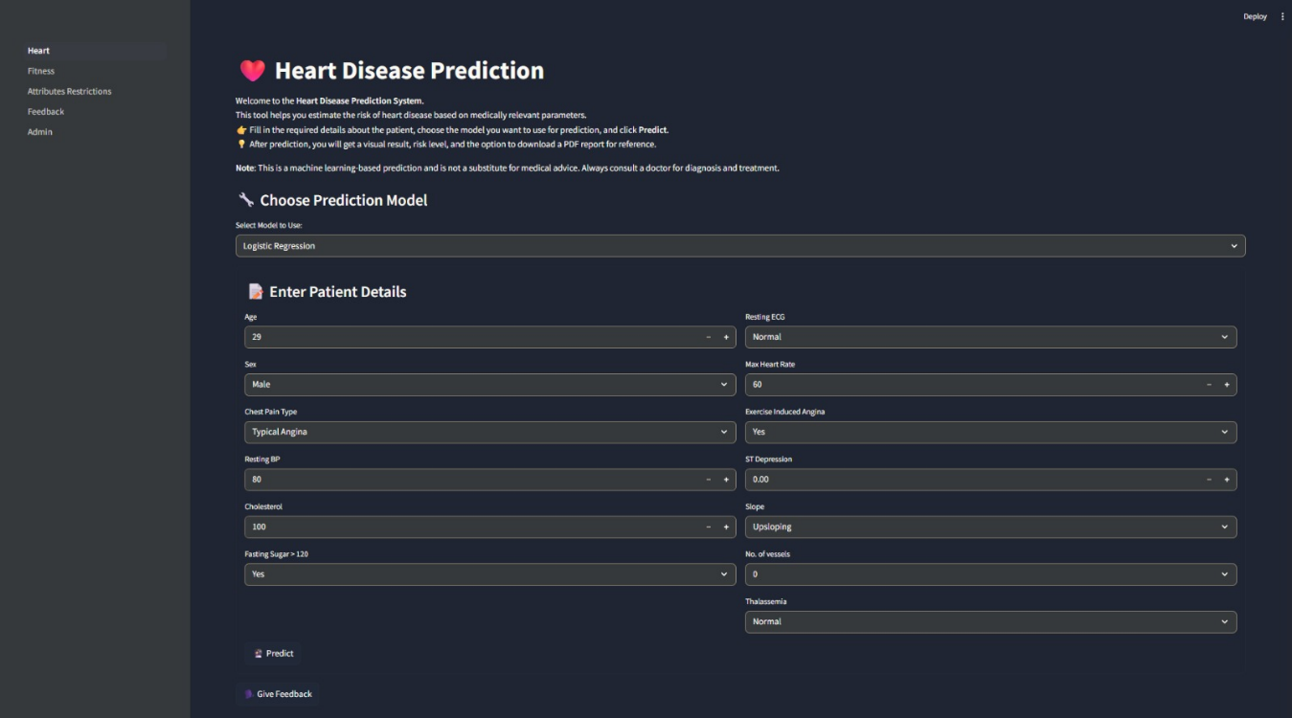

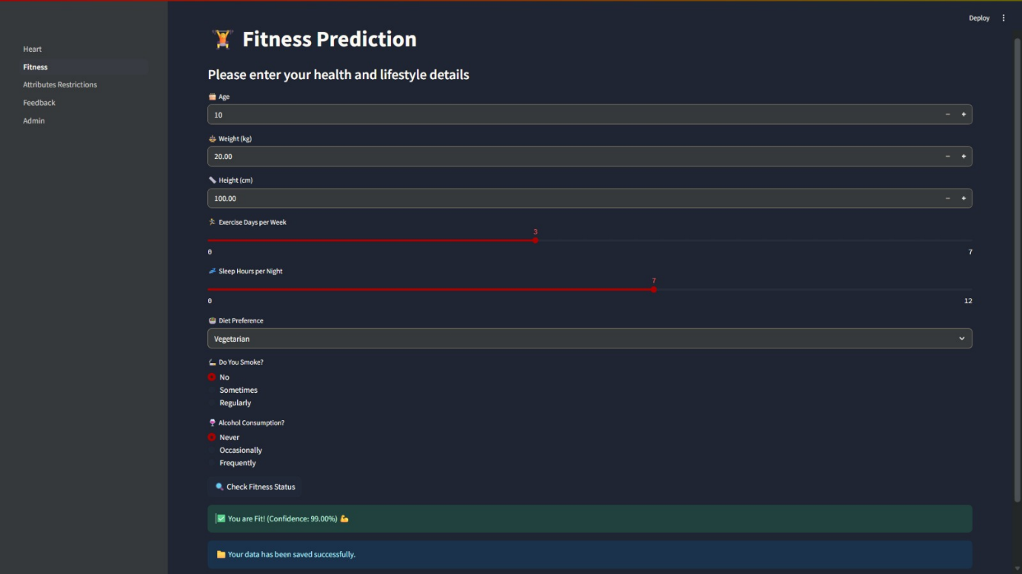

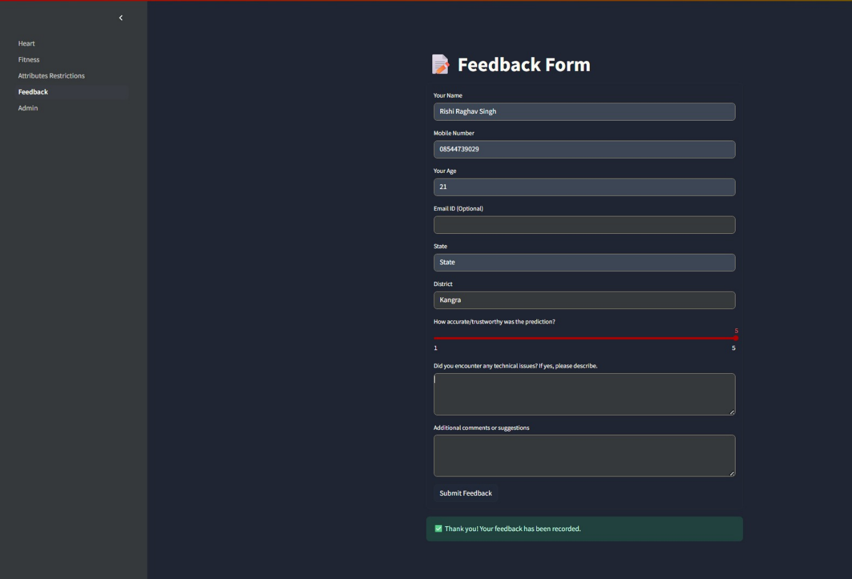

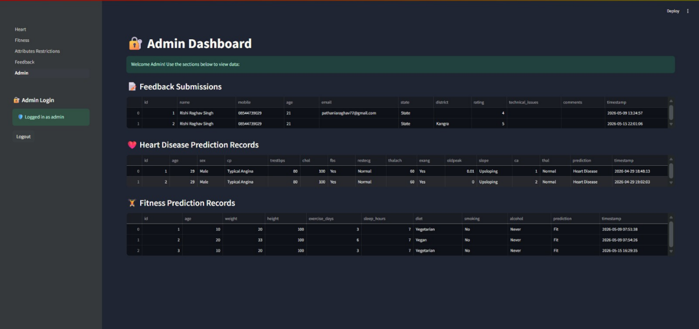

- Code Snippets

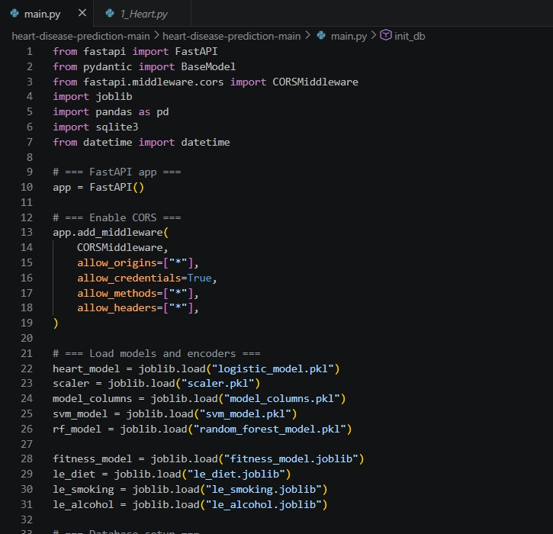

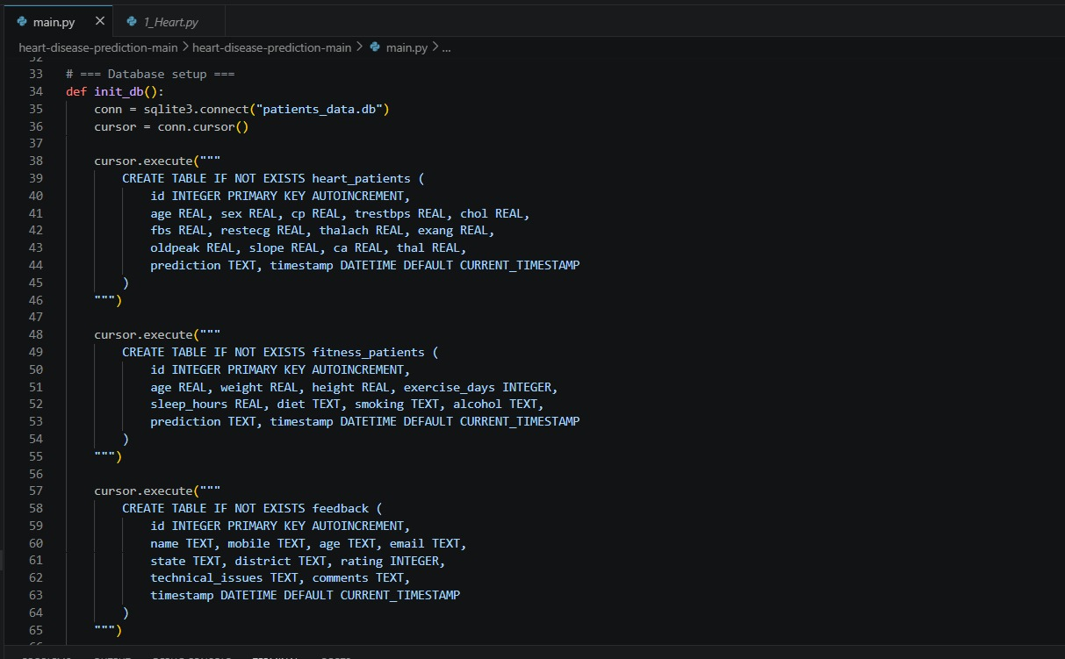

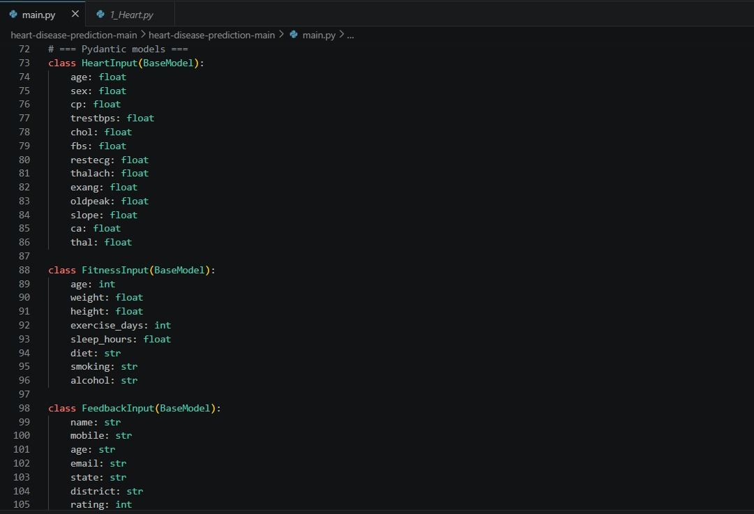

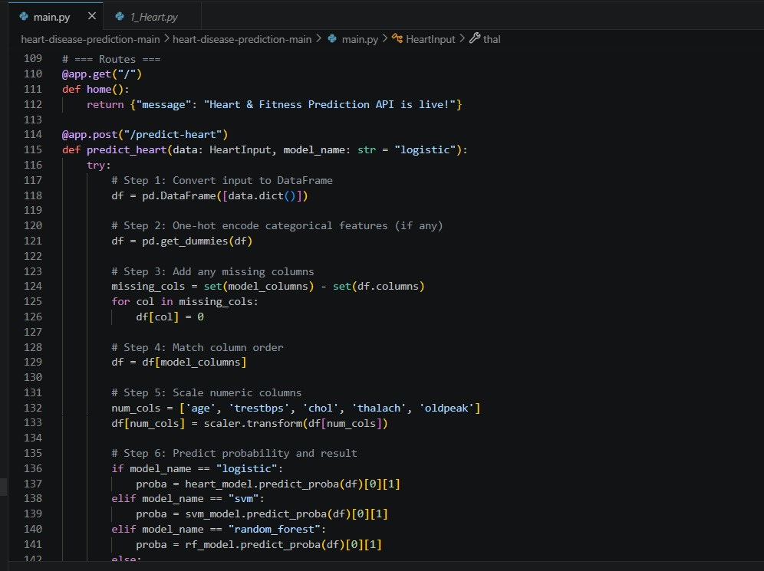

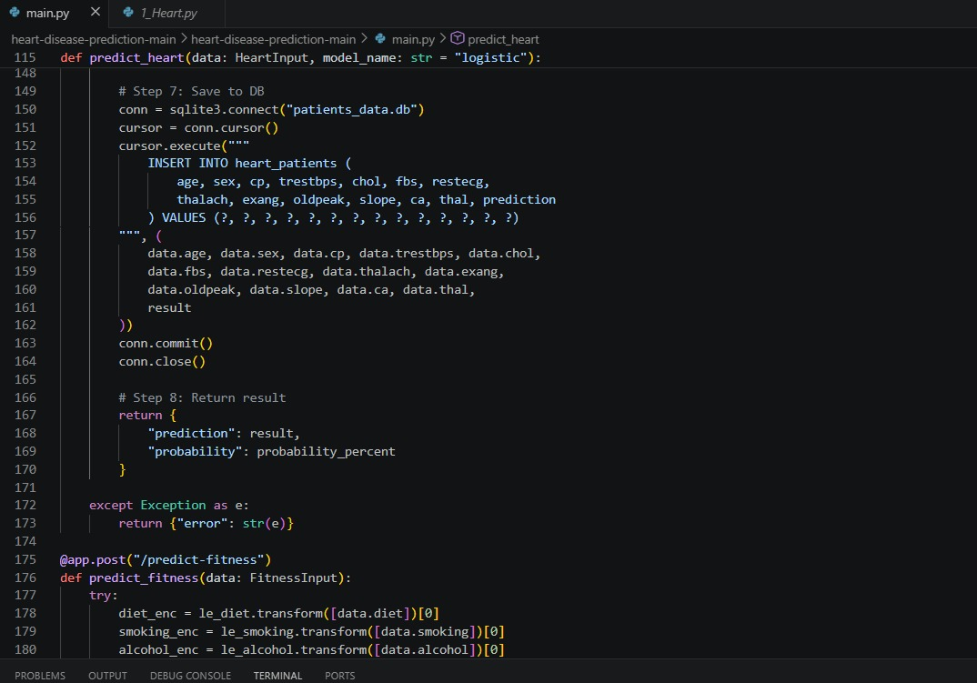
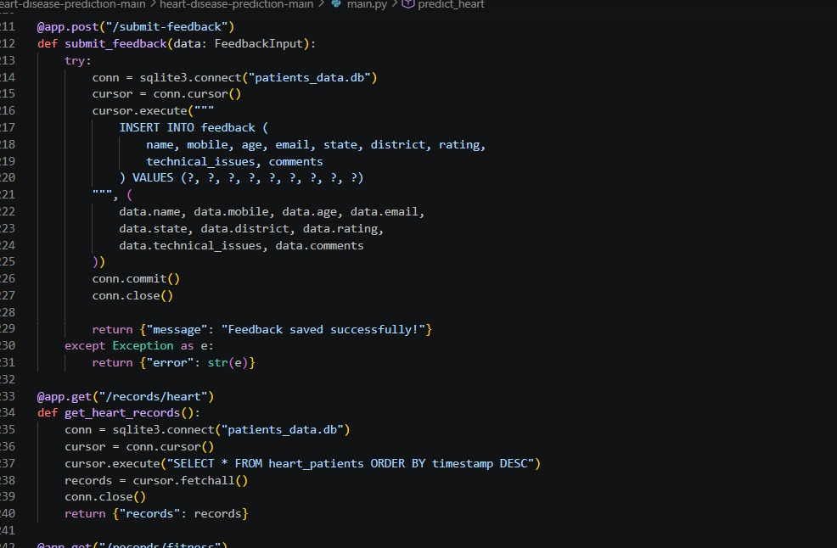

Conclusion and Future Scope

Conclusion
This report presented a Multi-Modal AI-Based Health Intelligence Framework that advances clinical AI along three axes: predictive performance, architectural completeness, and transparency. By combining a Disease Risk Assessment module trained on three ML classifiers with a Lifestyle Analysis module that generates a Lifestyle Risk Index from five behavioral metrics, the framework offers a more accurate and actionable risk assessment than any single-modal approach.
Random Forest was the top performer with 91.8% accuracy and AUC-ROC = 0.956. The LSA module demonstrated strong calibration (Spearman ρ = 0.71), and the CHRS aligned well with physician risk ratings (Cohen's κ = 0.74). With sub-60 ms response time, Streamlit deployment, SHAP explanations, real-time classifier switching, and exportable reporting, the system meets the requirements of a production-grade clinical decision-support tool.
The framework is most valuable in primary care settings where rapid, integrated risk identification can have outsized impact — particularly in under-resourced environments where specialist access is limited.

Future Scope
- Wearable Device Integration: Replace self-reported lifestyle inputs with real-time Bluetooth data (heart rate, SpO₂, step count) from consumer wearables for objective longitudinal risk tracking.
- Federated Learning: Train DRA models across multiple hospital systems without sharing raw patient data, enabling broader demographic coverage while maintaining privacy compliance.
- Deep Learning Fusion: Benchmark Tab Transformer and attention-based architectures combining ECG time-series, chest X-ray, and structured tabular data for specialist-level diagnostic accuracy on complex cases.
- EHR Integration via HL7 FHIR R4 APIs: Enable automated patient data ingestion and longitudinal risk monitoring embedded directly in existing clinical workflows.
- Mobile App Deployment via TensorFlow Lite: On-device Random Forest inference for offline risk assessment, extending access to rural and low-connectivity settings.

References
- World Health Organization, "Cardiovascular Diseases (CVDs)," Fact Sheet, Jan. 2023.
- World Economic Forum, The Global Economic Burden of Non-Communicable Diseases, WEF/HSP Report, 2011.
- E. J. Benjamin et al., "Heart Disease and Stroke Statistics — 2023 Update," Circulation, vol. 147, no. 8, pp. e93–e621, Feb. 2023.
- J. Moons et al., "Machine Learning for Cardiovascular Risk Prediction: Systematic Review," npj Digital Medicine, vol. 5, no. 1, pp. 1–13, 2022.
- R. Detrano et al., "International Application of a New Probability Algorithm for Diagnosis of Coronary Artery Disease," Am. J. Cardiology, vol. 64, no. 5, pp. 304–313, 1989.
- S. Palaniappan and R. Awang, "Intelligent Heart Disease Prediction System Using Data Mining Techniques," IEEE/ACS AICCSA, Doha, Qatar, pp. 108–115, 2008.
- S. Mohan, C. Thirumalai, and G. Srivastava, "Efficient Heart Disease Prediction using Hybrid Machine Learning Models," IEEE Access, vol. 7, pp. 81542–81554, 2019.
- D. Shah, S. Patel, and S. K. Bharti, "Heart Disease Prediction Using Machine Learning Techniques," SN Computer Science, vol. 1, no. 6, p. 345, Nov. 2020.
- V. V. Ramalingam, A. Dandapath and M. K. Raja, "A Survey on Heart Disease Prediction Using Machine Learning Techniques," Int. J. Eng. Technol., vol. 7, no. 2.8, pp. 684–687, 2018.
- Z. I. Attia et al., "An AI Algorithm for Identification of Patients with Atrial Fibrillation during Sinus Rhythm," Lancet, vol. 394, no. 10201, pp. 861–867, Sep. 2019.
- D. M. Lloyd-Jones et al., "Life's Essential 8: Updating the AHA Construct of Cardiovascular Health," Circulation, vol. 146, no. 5, pp. e18–e43, Aug. 2022.
- M. M. Poh et al., "Wearable Sensor for Continuous Monitoring of Electrodermal Activity," IEEE Trans. Biomed. Eng., vol. 57, no. 5, pp. 1243–1252, 2010.
- S. Cohen, T. Kamarck, and R. Mermelstein, "A Global Measure of Perceived Stress," Journal of Health and Social Behaviour, vol. 24, pp. 385–396, Dec. 1983.
- D. Dua and C. Graff, "UCI Machine Learning Repository," University of California, Irvine, 2019.
- National Health and Nutrition Examination Survey (NHANES) Protocol, U.S. CDC, Atlanta, GA.
- U.S. Food and Drug Administration, "AI/ML-Based Software as a Medical Device (SaMD) Action Plan," FDA, Washington, DC, Jan. 2021.

- Appendices

8.1 Appendix A – Dataset
- Cleveland Heart Disease Dataset
- 303 patient records
- 13 clinical features used for prediction

8.2 Appendix B – Algorithms Used
- Logistic Regression (LR)
- Support Vector Machine (SVM)
- Random Forest (RF)

8.3 Appendix C – Technologies Used
- Python
- Scikit-learn
- Streamlit
- Pandas
- NumPy
- SHAP

8.4 Appendix D – System Performance
- Best Model: Random Forest
- Accuracy: 91.8%
- AUC-ROC: 0.956
- Response Time: < 60 ms

